# 10D KAZAKHSTAN

# Day 1: Almaty

Your guide will meet you at the airport and transfer you to Almaty. You will visit the Green Bazaar, where it is impossible to refrain from shopping. Then the tour will continue in one of the oldest Almaty parks - Panfilov Park, where one of the most beautiful wooden building in the world - Zenkov Cathedral is located. After exploration of sport, cultural and business areas of the city you will get to the Medeo Gorge, well known due to the highest mountain skating rink in the world and Shymbulak resort. Next destination is the Kok-Tobe hill where the tallest TV tower in the world is located (if to count from the sea level) and where you will get by the picturesque winding mountain road. In Kok-Tobe Park you can stroll along the winding paths of the park, admire the magnificent panorama of the city from the special observation deck and visit the shop of national souvenirs. The tour ends with the short ride from the top of the hill to the center of the city by the famous Almaty cableway. Transfer to the hotel.

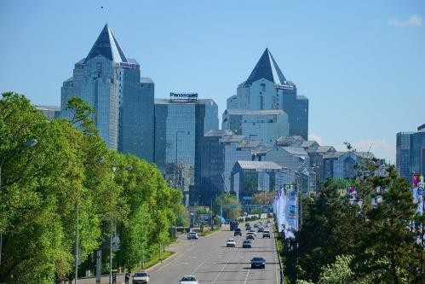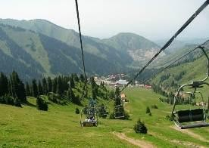

# Day 2: Almaty – Charyn Canyon – Almaty

Today you will have a day trip to Charyn Cabyons. It is one of the unique natural monuments of Kazakhstan. The canyon is about 12 million years old and surprises with its vertical cliffs, reminding the ancient castles, created by wind, sun and rain. It will take about 3 hours to reach the canyon. Meanwhile, you will hear a lot of interesting about the history and nature of the region, about Kazakh people, their life and traditions as well as have a lunch in a local cafe. And as soon as you see Charyn Canyon you will forget about this long way at once - so much you will be impressed with the beauty and splendor of the canyon. You can admire the grand panorama and then have a walk through the maze of the Castles Valley with its inaccessible walls overhanging you. In the evening is transfer to the hotel.

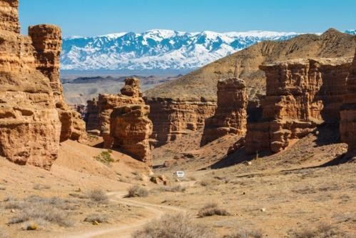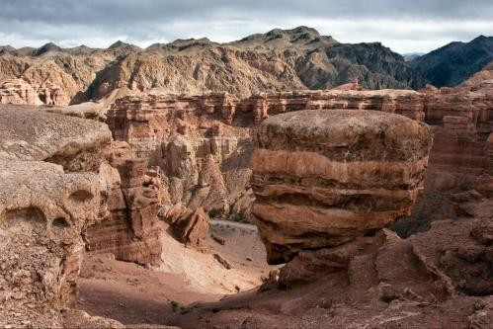

# Day 3: Almaty – Issyk lake – Almaty - Taraz

The tour route to one of the most beautiful gorges of Trans-Ili Alatau - Issyk Gorge lies along the Kuldja tract, where hundreds of years ago the trade caravans travelled. On the way you will visit the State Historical and Cultural Museum-Reserve “ISSYK”, where you will see the expositions dedicated to the history and culture of the Saka period, including a copy of Golden Man and

golden items, ancient ceramics, weapon, elements of horse equipment, as well as the model of Saka burial mound. Then the tour route will take you to an altitude of 1756 meters above sea level, to the beautiful mountain lake Issyk, located in the valley with the same name. On the lake you will enjoy the majestic beauty of its turquoise water surface and the Issyk Gorge, as well as listen to the details of the natural disaster of 1963. Also at the lake you will have a picnic and free time for recreation at nature. In the evening is to railway station. Night train to Taraz.

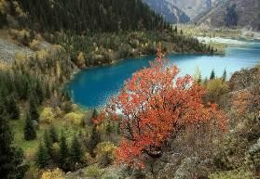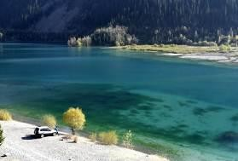

# Day 4: Taraz – Shymkent

Arrival to Taraz by morning train from Almaty. Meeting at the railway station and transfer to Taraz. Sightseeing at architectural monuments of XI-XII centuries, Aisha-Bibi Mausoleum, Babaja-Hatum Mausoleum, Karakhan Mausoleum, Tekturmas Historical Complex. Taraz is one of the oldest cities in Kazakhstan, the remains of which are hidden under the buildings of the modern city. Taraz, the ancient and the largest commercial and administrative center on the Silk Way in VII - VIII centuries, is dating back more than 2,000 years. There are more than 70 monuments of archaeology, history, architecture and monumental art in Taraz and surrounding area. Thus, a unique monument of medieval architecture of XI-XII centuries - Aisha Bibi Mausoleum - the only monument not only in Kazakhstan, but in the Central Asia, which is entirely decorated by terracotta and included in the UNESCO list of the most valuable historical and architectural monuments of mankind. Transfer to Shymkent. Accommodation is in the hotel.

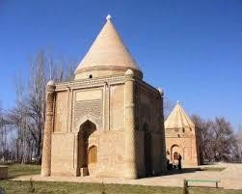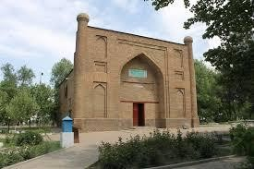

# Day 5: Shymkent – Shaulder – Turkestan – Shymkent

In the morning is transfer to Otrar Region, Shaulder Settlement (220 km). Sightseeing at Arystan-Bab Mausoleum (teacher and spiritual mentor of Khoja Ahmed Yasawi), archaeological site of the ancient settlement of Otrar. Otrar is the city where medieval philosopher and scientist Al-Farabi was born and lived. Otrar settlement was founded in IV century BC. Transfer to Turkestan (70 km). You will have sightseeing at "Azret-Sultan" historical and architectural complex, Mausoleum of Khoja Ahmed Yasawi, Turkestan ancient settlement, Necropolis, a fragment of the fortress wall, citadel with gates, Hammam, Hilvet underground mosque. Turkestan was founded around 500 AD at the crossroads of caravan routes from

Samarkand, Bukhara and Khiva in northern Kazakhstan. The city was known as the spiritual and political center of the Turkic-speaking people in the XVI-XVIII centuries, and was the capital of the Kazakh Khanate. Pilgrims say that three trips to Turkestan equal small Hajj to Mecca. Transfer to Shymkent. Overnight in Shymkent.

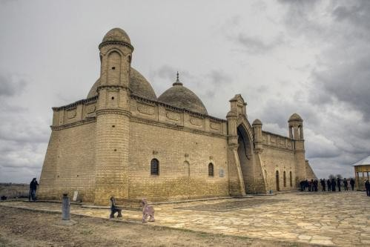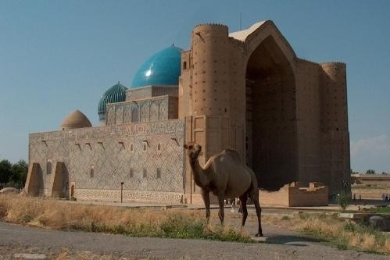

# Day 6: Shymkent – Sairam – Shymkent – Astana

After breakfast you will be transferred to Sairam Settlement (20 km). You will have sightseeing at Local History Museum "Sairam", Mar-Tobe, Ibrahim-Ata Mausoleum, Karashash-Ana Mausoleum, medieval minaret. Sairam Settlement is located near Shymkent, at the place of Ispidzhab - one of the largest centers of the Great Silk Road in the Middle Ages. Transfer to the foot of Kazygurt mountains. Sightseeing at Kamekalgan sacred place, Kazygurt mountain, "Noah's Ark", sanctifying rocks "Adam and Eve", stone statues of animals, the magic stone "Dastarkhan". Kazygurt is mountain massif having altitude of 1776 meters above sea level, located in the northern spurs of Talas Alatau. Transfer to the airport. In the evening you will have a flight to Astana. Meeting Astana and transfer to the hotel.

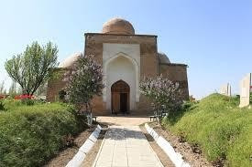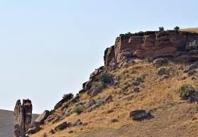

# Day 7: Astana

Today you will see the Constitution Square, where the president of Kazakhstan N.A.Nazarbayev announced the decision of transferring the capital of the country from Almaty to Asta na. You will visit the Presidential Centre of Culture of the Republic of Kazakhstan. At the museum you will see the Golden man, well known not only in the Kazakh steppe but also in all Central Asia. In order to better understand today’s life of the city, you will enter the largest and unique shopping center Khan Shatyr. Then you take the elevator to the top of the “Astana-Baiterek” monument, where you can admire the magnificent panorama of the Kazakhstan capital from the special observation deck. After lunch you will cross Ishym river and get to the Kazakh Eli Square. There you will visit another unique project - the Palace of Peace and Accord, and also see the extraordinary beauty of Khazret Sultan mosque. Final point of the excursion will be the Palace of Independence, where you can look at the far-reaching plans of the development of Astana in the hall "Layout Astana until 2030". Transfer to the hotel.

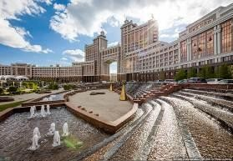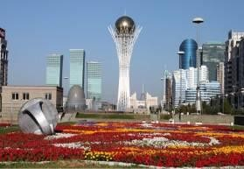

# Day 8: Astana – Borovoe – Astana

Full day guided tour to Burabai National park (Borovoe), which occupies 85000 hectares of northeastern part of Kokshetau elevation. There are 14 lakes in the park, each having surface area of more than 1 sq.km, and a large number of small lakes. On a way to the resort area which is in 270 km from Astana, the professional guide will give you an introduction to history of this region. On arrival you will visit the Khan’s pass and see "Burabay" mountain. On Abylaykhan Valley you will feast your eyes upon “Ush-kyz”, “Ok-Zhetpes”, “Zhumbaktas” rocks and “Kokshetau” mountain, each having the surprising legends reflecting history and identity of the Kazakh people. During the tour you will have lunch in a local cafe and 30- minute free time to walk in the wood. Further you wil have an easy hiking on “Bolektau” mountain, on the top of which the tremendous view of the “Borovoe” lake and its surroundings opens. In the evening is transfer to the hotel. In winter time the organization of tour depends on weather conditions.

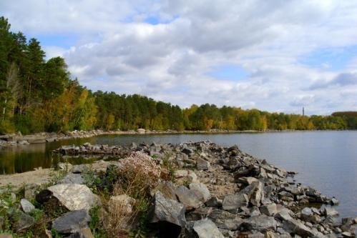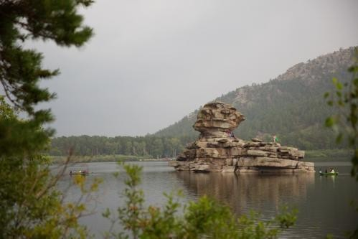

# Day 9: Astana – Alzhir – Astana

It is an Akmola camp for the wives of traitors of Motherland - one of the largest camps of Soviet Union and one of the three "islands" of the "Gulag Archipelago". The exposition of the museum is located on hall perimeter, that involves the visitor in a vicious circle and immerses in the historical past of Kazakhstan. At the end of excursion you will watch 20- minute documentary film. After lunch you will see the hunting with birds of prey is traditional for all Central Asian nomads. A rider with a golden eagle sitting on the wrist has always been a symbol of the Asian steppes. Falconry is practiced in many countries, but hunting with eagles on hares and foxes is an exceptional attraction of Kazakhstan. In Kazakhstan, hunters with eagles are called «Berkutchi». After demonstration of hunting you will get a complete picture of the traditional hunting with eagles, which has far-historical roots. In the evening is transfer to the hotel. If there are more than 20 people in a group, the hunter cannot demonstrate the hawk show.

# Day 10: Flight

Transfer to the airport.

# Transport:

02 pax – Sedan

04-14 pax – Sprinter 15-40 + 1 – Big Bus

# Hotels 3*,

**Price per person:**

15 + 1 pax – 915 $

20 + 1 pax – 785 $

25 + 1 pax – 705 $ without hawk show 30 + 1 pax – 645 $ without hawk show 35 + 1 pax – 610 $ without hawk show 40 + 1 pax – 480 $ without hawk show Single – 130 $

Early check- in – 30 $ Kazakhstan Single early check- in – 50 $

# Hotels 4*,

**Price per person:**

15 + 1 pax – 1 115 $

20 + 1 pax – 980 $

25 + 1 pax – 895 $ without hawk show 30 + 1 pax – 835 $ without hawk show 35 + 1 pax – 795 $ without hawk show 40 + 1 pax – 660 $ without hawk show Single – 200 $

Early check- in – 50 $ Kazzhol Single early check- in – 80 $

Half Board – 225 $ Full Board – 360 $

Flight Shymkent – Astana – from 90 $ (approx. price)

# Service includes:

* Transport
* Accommodation:

Almaty – “Kazakhstan” Hotel 3* / “Kazzhol” Hotel 4*

Shymkent – “Express city” Hotel 3* / “Shymkent” grand or “Megapolis” Hotel 4* Astana – “Ibis”Hotel 3* / “Kazzhol” Hotel 4*

* English speaking guide
* Entrances to all museums
* Mineral water during the tour
* Train tickets Almaty –Taraz (1 compartment for 4 pax)

# Service does not include:

* Air tickets
* Full board
* Single rooms
* Early check- in
* Travel insurance
* Visa and visa support